
Palmer Timeshare Claimants Group

October 2008

Dear

PALMER CLAIMANTS’ GROUP
OCTOBER 2008 - BULLETIN

I am writing to update you on the latest developments

Island Village Heights, Flamingo and Yucca Park

As you are aware, Island Village Heights and Flamingo were sold last year, and the final apartments at Yucca Park were sold in June 2008. There remains approximately €3m due to the tax and local authorities in relation to these developments, with a further €1m payable in staff redundancy costs.

Los Olivos

The sale agreement for Los Olivos was completed in August 2008 and the Joint Trustees will receive the sale proceeds of €8m in stage payments. To date, the sum of €1m has been received, with the next major payment due in January 2009 and the final payment receivable in July 2009.

Tenerife Royal Gardens

The Joint Trustees hope to complete the sale of Tenerife Royal Gardens by the end of this year at the agreed price of €6.25m. They have encountered problems with the licensing of the site as a Time Share, which has caused a delay in completion of the sale. However, they are hopeful that the sale will complete by December 2008.

Club La Paz

Club La Paz is still the subject of a criminal embargo, and so cannot be sold until the embargo is lifted. Lawyers are in negotiations with the Spanish authorities in order to resolve the matter, but the proceedings are very slow and time consuming.

We will write to you again in January 2009, unless there are any important developments to report to you in the meantime.

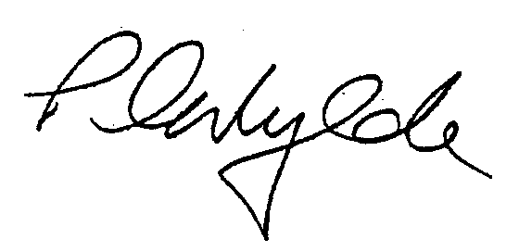
Yours sincerely

PETER WYLDE
PARTNER

